**Christenberry Elementary**

**School Supply List**

**2025-2026**

**Kindergarten (please do not send until assigned second staggered day)**

Large backpack

1 inch 3-ring binder with clear view pocket in front

24 Elmer's Non-scented glue sticks

4 boxes of tissues

2 packs of baby wipes

2 packs of large pink erasers

1 pair of Fiskars Scissors (rounded tip)

Boys - 1 box of quart size Ziploc bags

Girls - 1 box of sandwich size Ziploc bags

4 boxes of Crayola crayons (24 count)

1 box of Crayola washable markers

1 pack dry erase markers

Pencil Box

Reusable water bottle

2 pairs of over the ear headphones

2 packs of 24 Ticonderoga Pencils

**2nd Grade**

Large backpack

4 boxes of tissues

1 pack of baby wipes

1 pair of Fiskars scissors

2 pairs of headphones

1 pack of Elmer’s glue sticks

2 packs of Ticonderoga pencils

2 boxes of Crayola crayons (24 count)

Ziploc bags (girls-sandwich size, boys-gallon size)

Plastic pencil box

2 bottles of hand sanitizer

2 packs of black Expo Markers (fine tip)

Reusable water bottle

**1st Grade**

Large backpack

3 boxes of tissue

2 packs of baby wipes

1 pair Fiskars scissors

1 pack Elmer glue sticks

Full size plastic pencil box

4 boxes of Crayola crayons (24 count)

1 pack Ticonderoga Pencils

1 pack black fine tip Expo Markers

3 plastic folders (Red, Blue, Green)

Over the ear headphones labeled with name

1 pack pink erasers

1 bottle hand sanitizer

1 pack post it notes

Boys: 1 pack white card stock and sandwich size Ziploc bags

Girls: 1 container cleaning wipes and quart size Ziploc bags

Reusable water bottle labeled (less than 24 oz)



**3rd Grade**

Large backpack

4 boxes of tissue

1 pack baby wipes

2 containers of Clorox disinfectant wipes

2 packs of black dry erase markers

2 pack of #2 pencils

1 box of Crayola crayons (24 count)

Boys: Gallon Sized Ziploc Bags

Girls: Sandwich Sized Ziploc Bags

2 wide-ruled spiral bound notebooks-100 pages each

Over the ear headphones

Reusable water bottle

**4th Grade**

Large backpack

1 package of cap erasers

6 folders (different colors)

4 notebooks (single subject, wide rule)

1 pair of scissors

4 glue sticks

1 pack of markers

1 pack of crayons

1 pack of colored pencils

4 packs of #2 pencils

2 or more boxes of tissue

2 or more packs of disinfecting wipes

1 set of headphones

1 water bottle - plastic, kid size, with a sealable lid

1 pencil pouch

1 pack of black dry erase markers

**Encore and ELL Teachers**

Special Area teachers would also appreciate tissues, hand sanitizer, and baby wipes.

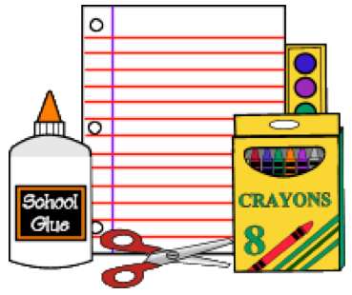

**5th Grade**

Large backpack

3 boxes of tissues

2 packs of Clorox wipes

1 pair of Fiskar scissors

16 glue sticks

1 set of headphones or earbuds

1 set of dry erase markers

1 set of eight tab dividers for the binder

4 packs of Ticonderoga pencils

2 packs of eraser tops

1 box of each type of Ziploc bags: sandwich, quart, and gallon size

1 pack each of markers, colored pencils, and crayons

6 composition lined notebooks, any color

4 Plastic heavy duty 3-prong pocket folder

Reusable water bottle